ABDELHAKIM BOUTOUZOUNT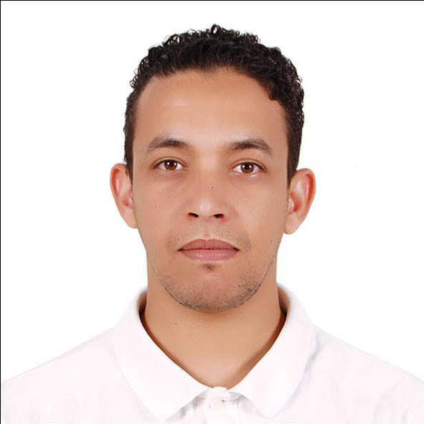  Sex : Male  Date of birth :12/03/1987  Nationality :Moroccan  CONTACT  Address:  N 337, HAY ALFARAH, AGADIR, 80100, MOROCCO  Phone:  00212674204725  Email:  hakhakim3@gmail.com  LANGUAGES  Arabic – C2  French – B2  English – B2 |  | .WORK EXPERIENCE  11/2018 - 04/2019  Working as a pastry commis in Royal Caribbean International (Symphony of the Seas)  08/2017 – 10/2018  Working as a pastry commis in Sofitel Agadir Royal Bay Resort  EDUCATION  2007 - 2009  - Pastry and bakery diploma at ISHR _hotel and restauration institute _AGADIR_Morocco  2005- 2007  - Geography studies at IBNO ZOHR university _AGADIR_MOROCCO  2002-2005  - High school degree at LALLA MERIEM college _GUELMIM_MOROCCO  ADDITIONAL SKILLS  Database operation: Microsoft Office Access  Job-related skills  Preparation of the basic creams; mousses and doughs; helping the chef de partie for making place of dessert for the buffet .making sure of ordination and cleaning the pastry reparts .  Taking of the list of ingredients from the deposit.

